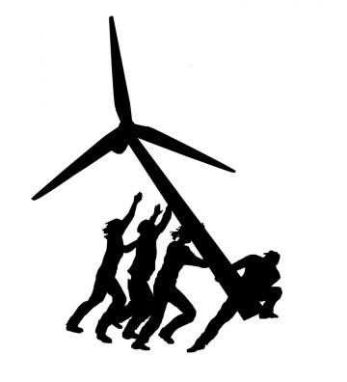Chicago Greens

**Press Release** March3, 2025

<http://www.illinoisgreens.org/i> For Information

Charles Paidock (312) 842-5036, (312) 714-7790 cell

[cpaidock@hotmail.com](mailto:cpaidock@hotmail.com)

<http://www.illinoisgreens.org/Chicago-Greens-Oppose-Elimination-of-All-Environmental-Measures-by-the-Current-Administration.html>

Position Paper for the 119th US Congress

“Chicago Greens Oppose the Elimination of All Environmental Measures by the Current Administration”

**Trump is abandoning efforts to reduce global warming, attacked longstanding environmental regulations, and has fired federal employees en masse who enforce those rules. Every corner of the world is now experiencing the effects of the rising temperatures. The speed and scale of Mr. Trump’s efforts to uproot climate policy is unprecedented. He has frozen funds appropriated by Congress for clean energy projects, taking particular aim at wind energy, the country’s largest source of renewable power. Mr. Trump has declared an energy emergency, giving himself the authority to fast-track the construction of oil and gas projects, fostering the supply as well as demand for fossil fuels.**

**Relevant articles from various sources:**

**‘Viciousness’ of Trump’s climate attacks stuns even his critics**

https://www.nytimes.com/2025/03/02/climate/trump-us-climate-policy-changes.html or

https://www.politico.com/news/2025/02/21/trump-gutted-climate-policy-across-federal-government-00204998

**‘Full on Fight Club’: How Trump Is Crushing U.S. Climate Policy**

https://dnyuz.com/2025/03/02/full-on-fight-club-how-trump-is-crushing-u-s-climate-policy/

**Trump's EPA Chief Seeks to Revoke Greenhouse Gas Rule Shaping US Policy**

https://www.msn.com/en-us/politics/government/trump-s-epa-chief-seeks-to-revoke-greenhouse-gas-rule-shaping-us-policy/ar-AA1zRkis?ocid=BingNewsSerp

**Here Are All of Trump’s Major Moves to Dismantle Climate Action**

https://time.com/7258269/trump-climate-policies-executive-orders/

**Analysis: As Trump slashes climate action, can states and cities pick up the slack?**

https://www.reuters.com/sustainability/boards-policy-regulation/analysis-trump-slashes-climate-action-can-states-cities-pick-up-slack-2025-02-27/